HEALTH & HEALING
DEVOTIONAL PROGRAM

1. Welcome & Introductory Prayer

“Cura”
Teu nome é minha cura,
Ó meu Deus,
E a lembrança de Ti,
Meu remédio.
…ó meu Deus,
E a lembrança de Ti,
Meu remédio.
Aproximar-me de Ti
É minha esperança,
E meu amor por Ti,
Meu companheiro.
Translation from the Portuguese:
“Thy name is my healing, O my God, and remembrance of Thee is my remedy. Nearness to Thee is my hope, and love for Thee is my companion.” – Bahá’u’lláh

Performed By Eric Lee Harper
With live video performance available @ http://vimeo.com/6805562
Or on his album “Romper a Madrugada”.

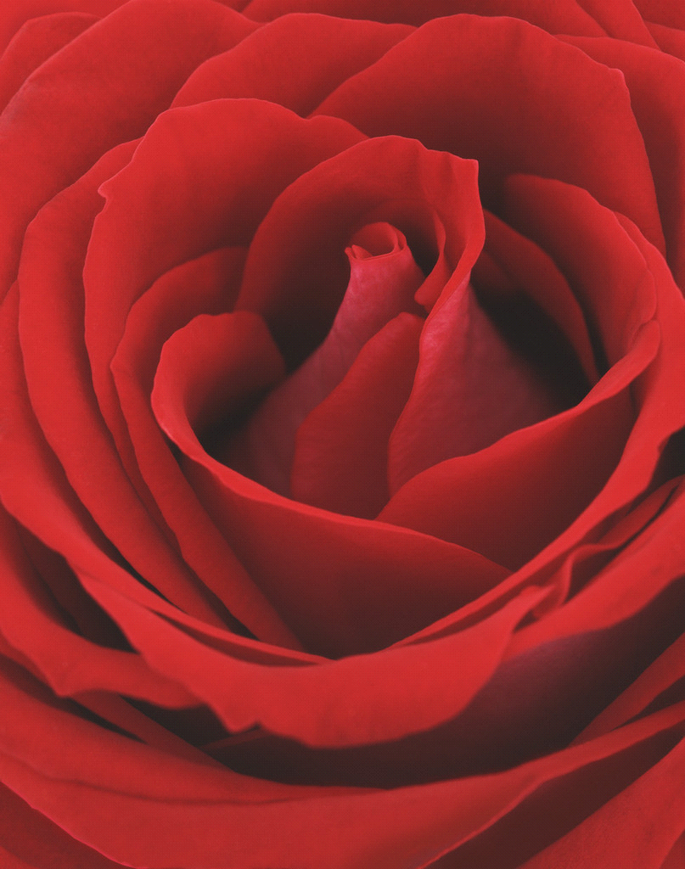
2. Reading: Health & Healing
* Praised be Thou, O Lord my God! I implore Thee, by Thy Most Great Name through Which Thou didst stir up Thy servants and build up Thy cities, and by Thy most excellent titles, and Thy most august attributes, to assist Thy people to turn in the direction of Thy manifold bounties, and set their faces towards the Tabernacle of Thy wisdom. Heal Thou the sicknesses that have assailed the souls on every side, and have deterred them from directing their gaze towards the Paradise that lieth in the shelter of Thy shadowing Name, which Thou didst ordain to be the King of all names unto all who are in heaven and all who are on earth. Potent art Thou to do as pleaseth Thee. In Thy hands is the empire of all names. There is none other God but Thee, the Mighty, the Wise.
I am but a poor creature, O my Lord; I have clung to the hem of Thy riches. I am sore sick; I have held fast the cord of Thy healing. Deliver me from the ills that have encircled me, and wash me thoroughly with the waters of Thy graciousness and mercy, and attire me with the raiment of wholesomeness, through Thy forgiveness and bounty. Fix, then, mine eyes upon Thee, and rid me of all attachment to aught else except Thyself. Aid me to do what Thou desirest, and to fulfill what Thou pleasest.
Thou art truly the Lord of this life and of the next. Thou art, in truth, the Ever-Forgiving, the Most Merciful.
(Bahá’u’lláh, Prayers and Meditations: XIX)

3. Prayers and Readings

Open session – friends may choose any prayer or reading that they would like to recite. This may include the selected writings from the Bahá'í Faith included below.

*O God, my God! I beg of Thee by the ocean of Thy healing, and by the splendors of the Daystar of Thy grace, and by Thy Name through which Thou didst subdue Thy servants, and by the pervasive power of Thy most exalted Word and the potency of Thy most august Pen, and by Thy mercy that hath preceded the creation of all who are in heaven and on earth, to purge me with the waters of Thy bounty from every affliction and disorder, and from all weakness and feebleness.

Thou seest, O my Lord, Thy suppliant waiting at the door of Thy bounty, and him who hath set his hopes on Thee clinging to the cord of Thy generosity. Deny him not, I beseech Thee, the things he seeketh from the ocean of Thy grace and the Daystar of Thy loving-kindness.

Powerful art Thou to do what pleaseth Thee. There is none other God save Thee, the Ever-Forgiving, the Most Generous.
(Bahá’u’lláh Prayers and Meditations p.265)

*GOD loveth those who are pure. Naught in the Bayan and in the sight of God is more loved than purity and immaculate cleanliness....

God desireth not to see, in the Dispensation of the Bayan, any soul deprived of joy and radiance. He indeed desireth that under all conditions, all may be adorned with such purity, both inwardly and outwardly, that no repugnance may be caused even to themselves, how much less unto others.
(The Báb, Selections from the Writings of the Báb, p.79)

*God hath enjoined upon you to observe the utmost cleanliness, to the extent of washing what is soiled with dust, let alone with hardened dirt and similar defilement. Fear Him, and be of those who are pure. Should the garb of anyone be visibly sullied, his prayers shall not ascend to God, and the celestial Concourse will turn away from him. Make use of rose-water, and
of pure perfume; this, indeed, is that which God hath loved from the beginning that hath no beginning, in order that there may be diffused from you what your Lord, the Incomparable, the All-Wise, desireth.
(Bahá’u’lláh, The Kitáb-i-Aqdas, p 47-48)

*Observe how pleasing is cleanliness in the sight of God, and how specifically it is emphasized in the Holy Books of the Prophets; for the Scriptures forbid the eating or the use of any unclean thing.
('Abdu'l-Bahá, Selections from the Writings of
'Abdu'l-Bahá, p. 147-148)

*Now let us speak of material healing. The science of medicine is still in a condition of infancy; it has not reached maturity. But when it has reached this point, cures will be performed by things which are not repulsive to the smell and taste of man -- that is to say, by aliments, fruits and vegetables which are agreeable to the taste and have an agreeable smell. For the provoking cause of disease -- that is to say, the cause of the entrance of disease into the human body -- is either a physical one or is the effect of excitement of the nerves.

But the principal causes of disease are physical, for the human body is composed of numerous elements, but in the measure of an especial equilibrium. As long as this equilibrium is maintained, man is preserved from disease; but if this essential balance, which is the pivot of the constitution, is disturbed, the constitution is disordered, and disease will supervene.

For instance, there is a decrease in one of the constituent ingredients of the body of man, and in another there is an increase; so the proportion of the equilibrium is disturbed, and disease occurs. For example, one ingredient must be one thousand grams in weight, and another five grams, in order that the equilibrium be maintained. The part which is one thousand grams diminishes to seven hundred grams, and that which is five grams augments until the measure of the equilibrium is disturbed; then disease occurs. When by remedies and treatments the equilibrium is reestablished, the disease is banished. So if the sugar constituent increases, the health is impaired; and when the doctor forbids sweet and starchy foods, the sugar constituent diminishes, the equilibrium is reestablished, and the disease is driven off. Now the readjustment of these constituents of the human body is obtained by two means -- either by medicines or by aliments; and when the constitution has recovered its equilibrium, disease is banished. All the elements that are combined in man exist also in vegetables; therefore, if one of the constituents which compose the body of man diminishes, and he partakes of foods in which there is much of that diminished constituent, then the equilibrium will be established, and a cure will be obtained. So long as the aim is the readjustment of the constituents of the body, it can be affected either by medicine or by food.

The majority of the diseases which overtake man also overtake the animal, but the animal is not cured by drugs. In the mountains, as in the wilderness, the animal's physician is the power of taste and smell. The sick animal smells the plants that grow in the wilderness; he eats those that are sweet and fragrant to his smell and taste, and is cured. The cause of his healing is this. When the sugar ingredient has become diminished in his constitution, he begins to long for sweet things; therefore, he eats an herb with a sweet taste, for nature urges and guides him; its smell and taste please him, and he eats it. The sugar ingredient in his nature will be increased, and health will be restored.

It is, therefore, evident that it is possible to cure by foods, aliments and fruits; but as today the science of medicine is imperfect, this fact is not yet fully grasped. When the science of medicine reaches perfection, treatment will be given by foods, aliments, fragrant fruits and vegetables, and by various waters, hot and cold in temperature.

This discourse is brief; but, if God wills, at another time, when the occasion is suitable, this question will be more fully explained.
('Abdu'l-Bahá, Some Answered Questions, p. 257-260)

*That which God hath ordained as the sovereign remedy and mightiest instrument for the healing of the world is the union of all its peoples in one universal Cause, one common Faith. This can in no wise be achieved except through the power of a skilled, an all-powerful, and inspired Physician. By My life! This is the truth, and all else naught but error. Each time that Most Mighty Instrument hath come, and that Light shone forth from the Ancient Dayspring, He was withheld by ignorant physicians who, even as clouds, interposed themselves between Him and the world. It failed therefore, to recover, and its sickness hath persisted until this day. They indeed were powerless to protect it, or to effect a cure, whilst He Who hath been the Manifestation of Power amongst men was withheld from achieving His purpose, by reason of what the hands of the ignorant physicians have wrought.
(Bahá’u’lláh, Epistle to the Son of the Wolf, p. 62)

*All true healing comes from God! There are two causes for sickness, one is material, the other spiritual. If the sickness is of the body, a material remedy is needed, if of the soul, a spiritual remedy.

If the heavenly benediction be upon us while we are being healed then only can we be made whole, for medicine is but the outward and visible means through which we obtain the heavenly healing. Unless the spirit be healed, the cure of the body is worth nothing. All is in the hands of God, and without Him there can be no health in us!

There have been many men who have died at last of the very disease of which they have made a special study. Aristotle, for instance, who made a special study of the digestion, died of a gastronomic malady. Aviseu was a specialist of the heart, but he died of heart disease. God is the great compassionate Physician who alone has the power to give true healing.
('Abdu'l-Bahá, Paris Talks, p. 19)

*O God! The Supreme Knower! The Ancient Tongue speaks that which will satisfy the wise in the absence of doctors.
O People, do not eat except when you are hungry. Do not drink after you have retired to sleep. Exercise is good when the stomach is empty; it strengthens the muscles. When the stomach is full it is very harmful.
Do not neglect medical treatment, when it is necessary, but leave it off when the body is in good condition. Do not take nourishment except when (the process of) digestion is completed. Do not swallow until you have thoroughly masticated your food. Treat disease first of all through diet, and refrain from medicine. If you can find what you need for healing in a single herb do not use a compound medicine. Leave off medicine when the health is good, and use it in case of necessity. If two diametrically opposite foods are put on the table do not mix them. Be content with one of them. Take first the liquid food before partaking of solid food. The taking of food before that which you have already eaten is digested is dangerous....When you have eaten walk a little that the food may settle.
That which is difficult to masticate is forbidden by the wise. Thus the Supreme Pen commands you. A light meal in the morning is as a light to the body.
Avoid all harmful habits: they cause unhappiness in the world. Search for the causes of disease. This saying is the conclusion of this utterance.
(Star of the West, vol. 13, no. 9, December 1922, p. 252)
*In God must be our trust. There is no God but Him, the Healer, the Knower, the Helper....Nothing in earth or heaven is outside the grasp of God.

O doctor! In treating the sick, first mention the name of God, the Possessor of the Day of Judgment, and then use what God hath destined for the healing of His creatures. By My Life! The doctor who has drunk from the Wine of My Love, his visit is healing, and his breath is mercy and hope. Cling to him for the welfare of the constitution. He is confirmed by God in his treatment.
(Star of the West, vol. 21, no. 5, August 1930, p. 160)

4. Closing Prayer

*Thy name is my healing, O my God, and remembrance of Thee is my remedy. Nearness to Thee is my hope, and love for Thee is my companion. Thy mercy to me is my healing and my succor in both this world and the world to come. Thou, verily, art the All-Bountiful, the All-Knowing, the All-Wise.
(Bahá’u’lláh, Compilations, Baha'i Prayers, p. 85)

5. Social Portion

Refreshments and conversation.

